Film Analysis Paper over Metropolis by Fritz Lang

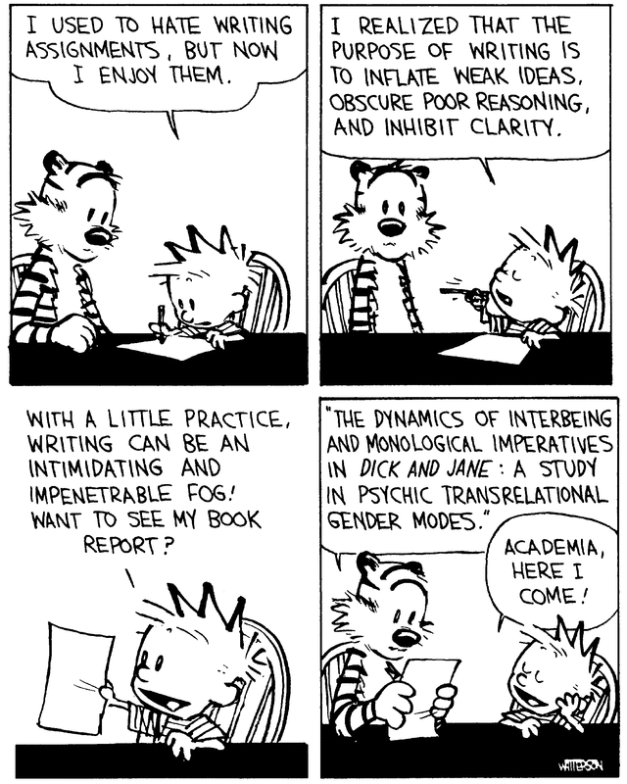
Directions: Choose one of the two concepts below and compose a well written, multi-paragraph film analysis paper over Fritz Lang’s Metropolis using the literary analysis lens of Feminism (Gender) or Marxism (social class). Remember to use your academic vocabulary as you discuss the film. Be sure to back up your claim(s) with evidence from the text and avoid using personal pronouns such as I, me, we, us, our, and you. Also, be sure to double space as you write. Papers not properly formatted will not be graded until they are rewritten.

Questions to consider when evaluating Marxism ideology in the film:
- How are class differences presented in the work? Are characters aware or unaware of the economic and social forces that affect their lives?
- How do economic conditions determine the characters’ lives?
- What ideological (big ideas) values are explicit or implicit in the text?
- Does the work challenge or affirm the social order it describes?

Questions to consider when evaluating Feminist ideology (or gender) in the film:
- How are the lives of men and women portrayed in the work? Do the men and women in the film accept or reject these roles?
- What attitudes are explicit or implicit concerning the relationships between men and women in the text?
- Are these relationships sources of conflict? Do these relationships provide resolutions to the conflict(s)?
- Does the work challenge or affirm traditional ideas about men and women and society and their respective roles?

OMG! I DON’T KNOW WHAT TO DO!!!
Students are so used to being given essay prompts by their teachers that they are sometimes confused the first time they are asked to write an analysis essay, but are not given a prompt. What do you write about? Where do you begin? These are good questions, so don’t feel bad if you are confused. In college you will almost never be given a prompt!
When a teacher asks you to write an analysis paper the prompt is implied in the analysis. You can write about anything you want (in this case Marxism or Feminism) as long as you make a strong, arguable claim and back up that claim and your textual analysis with evidence from the text.
You are analyzing a piece of literature (whether it be a movie, novel, short story, play or poem) when you talk about what you think that piece of literature (or author) is trying to do or say, why the author is trying to do or say that thing, and how the author is going about doing it. Any claim is valid as long as you back up your claim with evidence from the text.
You always start by making a claim (writing a thesis statement). In this case, make a claim about the portrayal of women in the text or what you think the text is trying to say about social class. Then be prepared to talk in your body paragraphs about how and why the author does what they do. Be sure to always back up your claims and your analysis with hard evidence from the text!

