2014 Introduction to Film Studies Response Question over Sunset Boulevard
(Suggested Time – 50 minutes. This is a timed response and counts as a test worth 80% of your overall grade)
Consider the film Sunset Boulevard by Billy Wilder (1950). Explore how a character’s psychological or emotional makeup defines the film’s primary conflict. Avoid mere plot summary. Avoid using personal pronouns as you write such as I, we, me, my, us, our, you. Use both your literary and film academic vocabulary as you write and highlight or underline any vocabulary words that you use in your essay. Also, underline or highlight your thesis statement. Be sure to double space as you write.

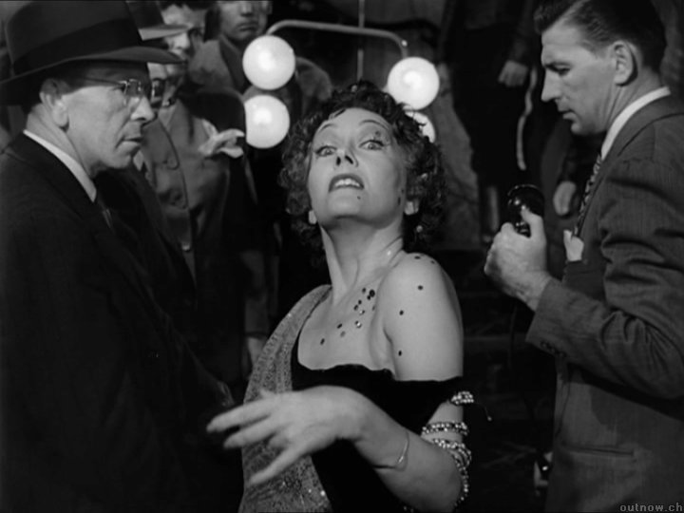

Example introductory paragraph and thesis for the prompt above over the movie The Hurt Locker. The thesis statement is underlined:
In Kathryn Bigelow’sTthe Hurt Locker (2008), Sergeant William James, a specialist at defusing bombs, flaunts his risk-taking, daredevil approach to his job, which raises concerns among his fellow soldiers. James’s macho bravado is his way of dealing with his emotional disconnectedness. The film visually expresses the predicament of this rugged, yet highly vulnerable man, through the cumbersome gear he wears to disable bombs. That protective shell insulates him from the world, hiding the feelings he cannot acknowledge openly, but also weighs him down physically and emotionally.

2014 Introduction to Film Studies Response Question over Sunset Boulevard
(Suggested Time – 50 minutes. This is a timed response and counts as a test worth 80% of your overall grade)
According to critic Northrop Frye, “tragic heroes are so much the highest points in their human landscape that they seem the inevitable conductors of the power about them, great trees more likely to be struck by lightning than a clump of grass. Conductors may of course be instruments as well as victims of the divine lightning.” Consider the film Sunset Boulevard by Billy Wilder (1950) in which a tragic figure functions as an instrument of the suffering of others. Then write an essay in which you explain how the suffering brought upon others by that figure contributes to the tragic vision of the work as a whole. Avoid mere plot summary. Avoid using personal pronouns as you write such as I, we, me, my, us, our, you. Use both your literary and film academic vocabulary as you write and highlight or underline any vocabulary words that you use in your essay. Also, underline or highlight your thesis statement. Be sure to double space as you write.

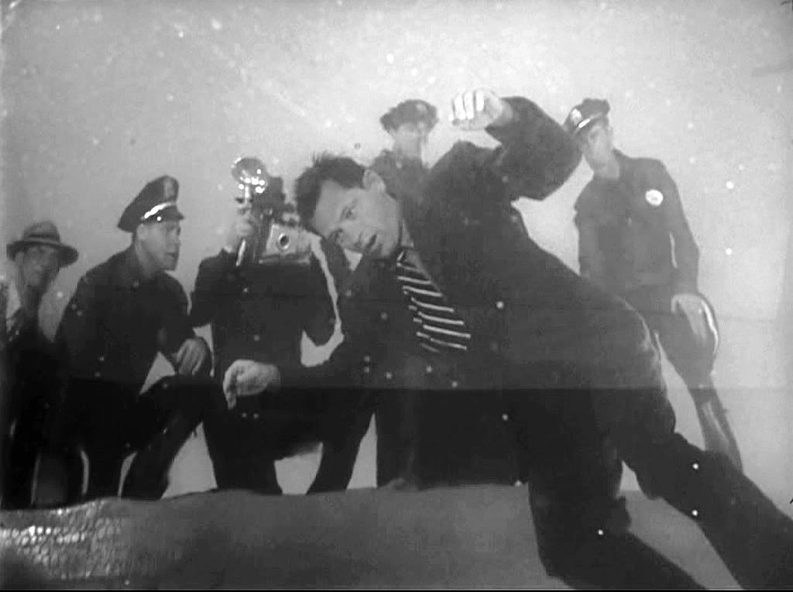

2014 Introduction to Film Studies Response Question over Sunset Boulevard
(Suggested Time – 50 minutes. This is a timed response and counts as a test grade worth 80% of your overall grade)
Critic Roland Barthes has said, “Literature is the question minus the answer.” Think back to your practice in writing leveled questions over the film Sunset Boulevard by Billy Wilder (1950). Considering Barthes’ observation, write an essay in which you analyze a central question the work raises and the extent to which it offers any answers. Explain how the director’s treatment of this question affects your understanding of the work as a whole. Avoid mere plot summary. Avoid using personal pronouns as you write such as I, we, me, my, us, our, you. Use both your literary and film academic vocabulary as you write and highlight or underline any vocabulary words that you use in your essay. Also, underline or highlight your thesis statement. Be sure to double space as you write.

